Görkem Enes Bektaş
bektasgorkemenes@gmail.coım
Politechnika Czestochowa

Berke Can Kaya
bluten07@gmail.com
Politechnika Czestochowa

Signal analysis and data processing

Laboratory Class - Experiment 3

Autocorrelation
Introduction

Compulsory Tasks:
- Perform a selection of the maximum correlation distance T_{max} for diffrent signal types.
The selection of τ_{max}​ is crucial for determining the range within which the autocorrelation remains meaningful. For periodic, random, and compound signals, it was observed that:
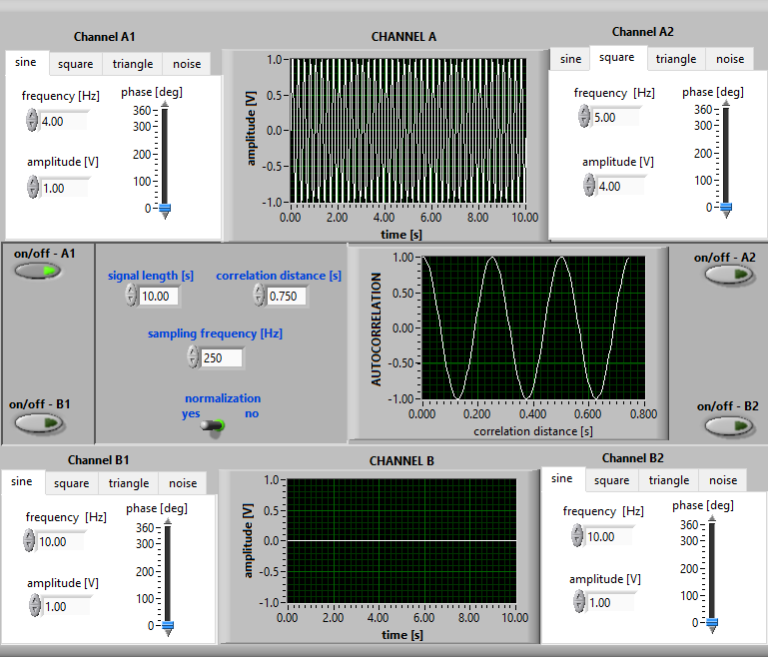
Figure 1Periodic signal
In the figure 1, τ_{max​} corresponds to the signal's fundamental period, as periodic signals exhibit repetitive patterns.

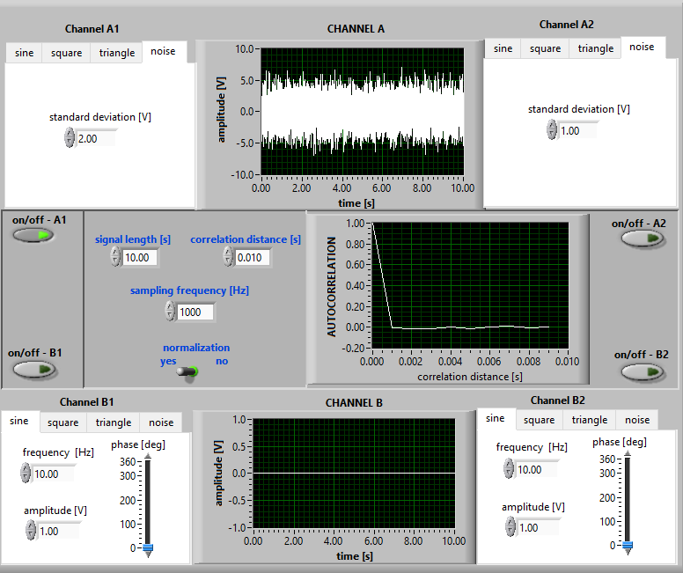
Figure 2 Random signal
In the figure 2, τ_{max} is minimal due to the lack of structure, reflecting rapid decorrelation.
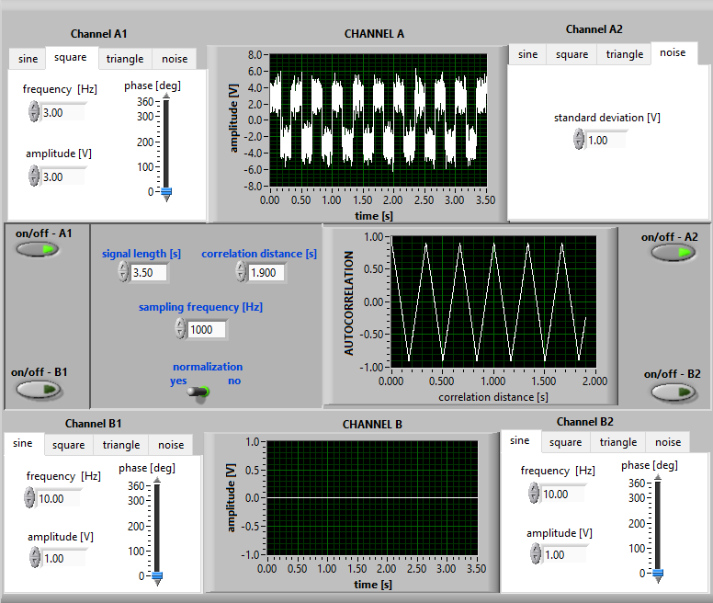
Figure 3 Compound signal
In the figure 3, A blend of deterministic and random components results in intermediate τmax, balancing between order and randomness.
- For the deterministic signals tested, the condition τmax≪T was satisfied, ensuring sufficient accuracy in estimating the autocorrelation function. This is critical for avoiding aliasing or inaccuracies during calculation.
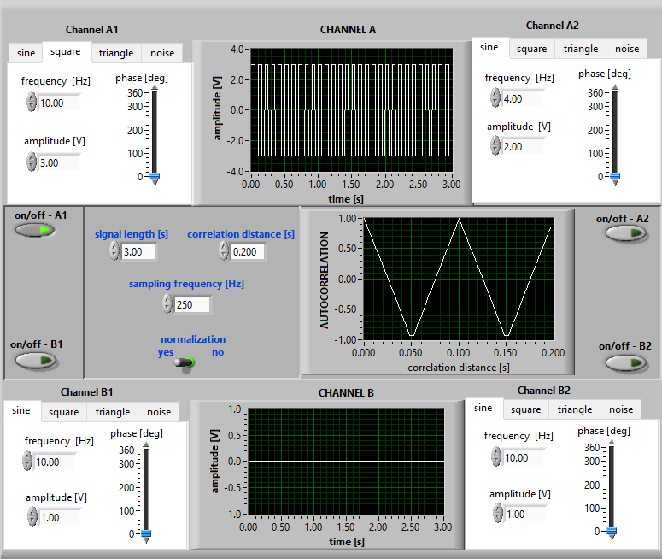
- A stationarity test was conducted on compound signals by varying the signal length. Results indicate:
• Increased signal length enhances autocorrelation stability and smoothness.
• Reduced standard deviation improves signal visibility in the presence of noise

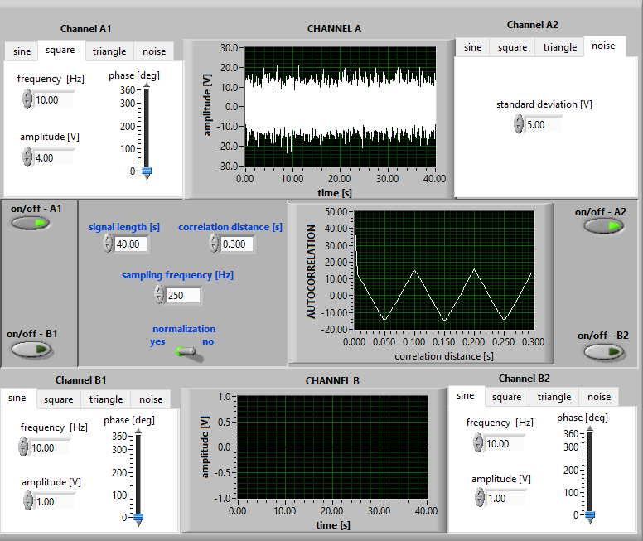

When the signal length increases or or when standard deviation decreases, signal signal visibility becomes better.

- Determine the Q_{xx(T)} distributions for various signal types:
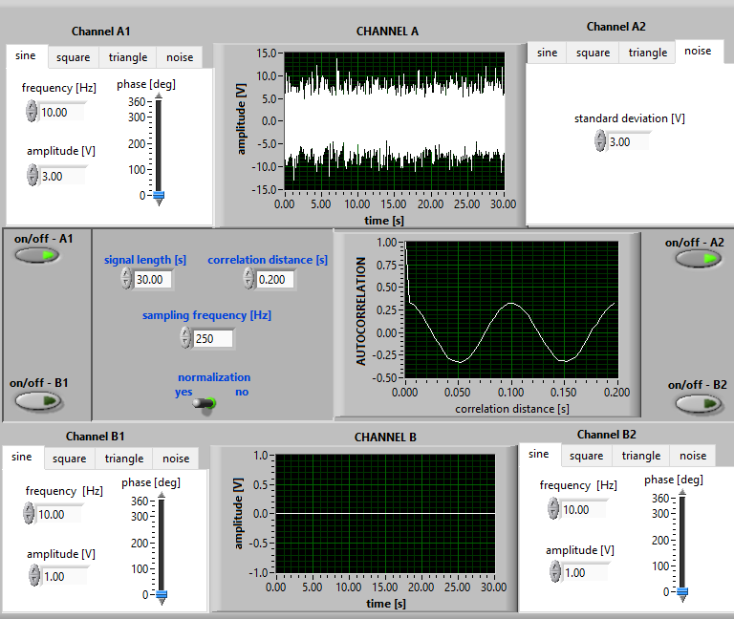
Figure 4 signal type; sine + noise
Noise disrupts the periodic structure of the sine wave, resulting in a flatter and more scattered autocorrelation function. However, the regular periodicity of the sine signal still produces identifiable peaks in the autocorrelation despite the noise.
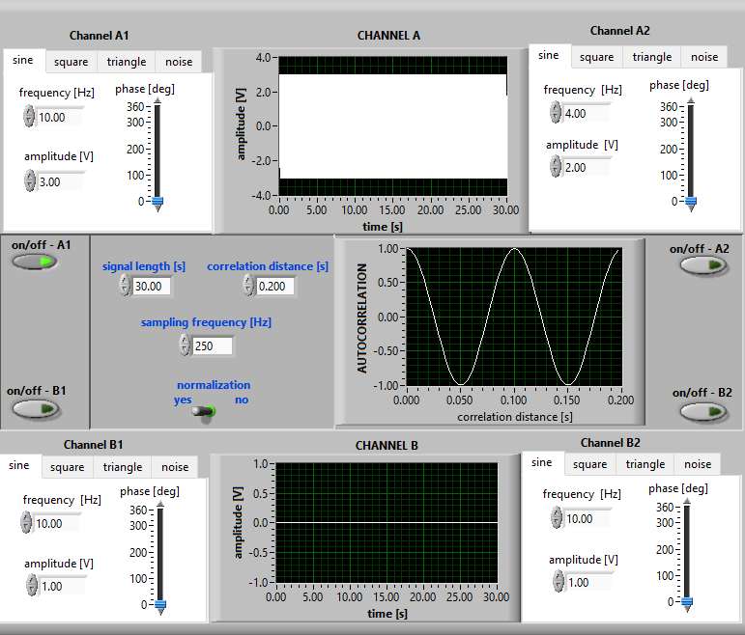
Figure 5 signal type; sine + sine
When two sine waves (with different or identical frequencies) are combined, the autocorrelation function exhibits a regular repeating structure based on the periods of the fundamental components. Differences in phase or frequency between the two signals can create distinct patterns in the autocorrelation function.
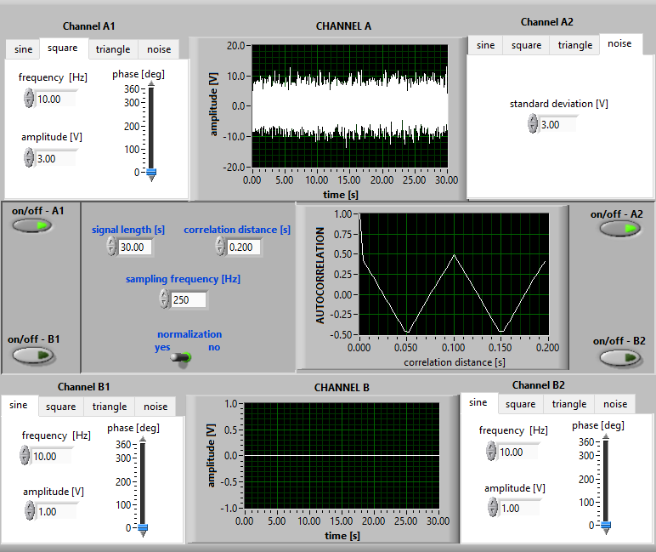
Figure 6 signal type; square+noise
Square waves feature abrupt transitions, and the autocorrelation function reflects these transitions with sharp corners. When noise is added, the sharp edges of the square wave are smoothed, and the autocorrelation function becomes less defined.
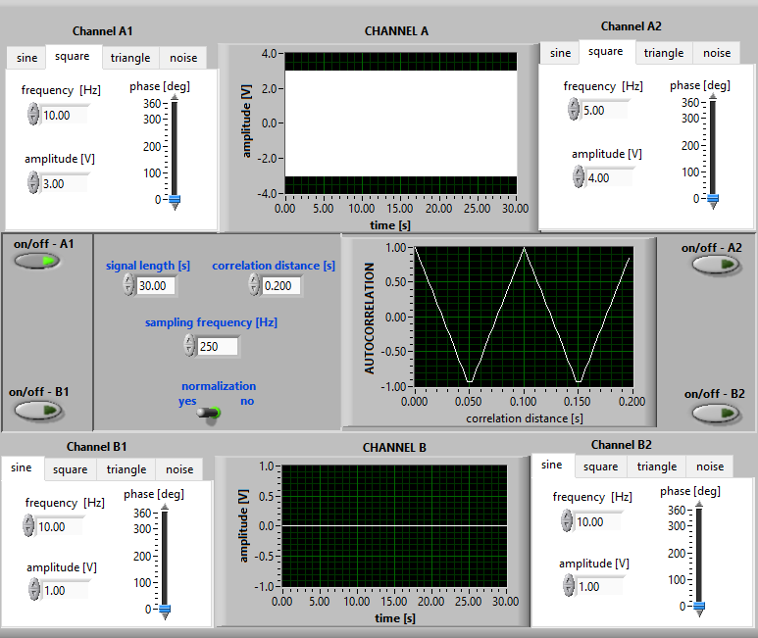
Figure 7 signal type; square + square
The combination of two square waves results in a structured autocorrelation function. If the waves have different periods, this difference introduces additional patterns in the function. Without noise, the autocorrelation remains clean and well-defined.
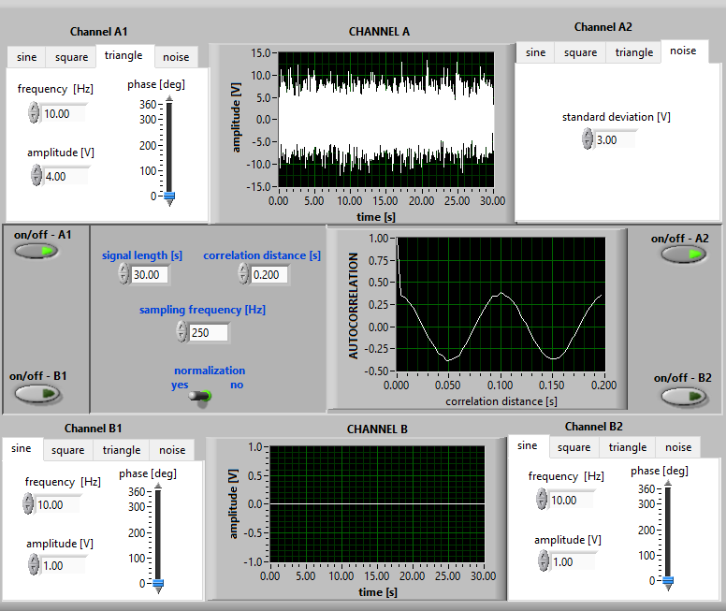
Figure 8 signal type; triangle + noise
A triangle wave, with its smoother transitions, produces a symmetric and regular autocorrelation function. The presence of noise disrupts this smoothness, making the autocorrelation less uniform and more irregular.
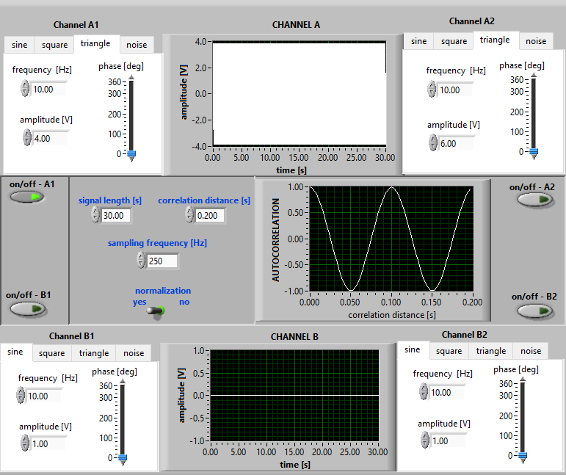
Figure 9 signal type; triangle + triangle
When two triangle waves are combined, the autocorrelation function clearly reflects the symmetric and continuous features of the triangle wave. In the absence of noise, this autocorrelation function is among the smoothest and most well-defined.
- The relationship between standard deviation (σ) and noise power was analyzed:
- As σ\sigmaσ increases, noise dominates, causing the autocorrelation function to flatten.
- Higher noise levels decrease the correlation's characteristic amplitude (ϵ\epsilonϵ), diminishing signal distinguishability.
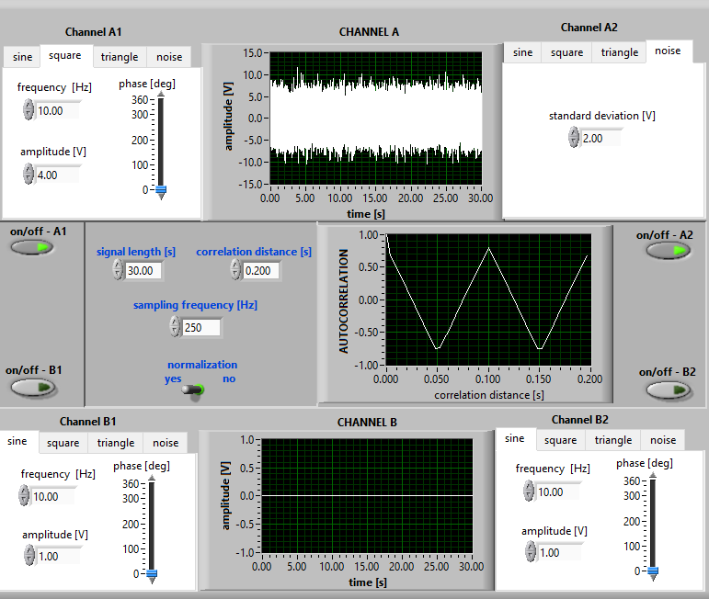
Standard deviation = 2 Amplitude = 4
N = σ_{sq}² + σ_{noise}² = 4 + 16 = 20
ε = $\frac{σnoise^2 }{N} x 100$ = $\frac{4 }{20} x 100=\%20$
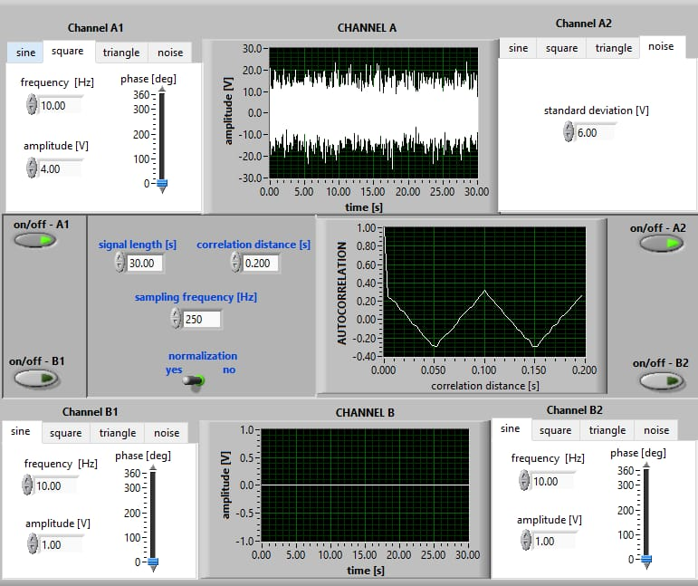
Standard deviation = 6 Amplitude = 4
N = σ_{sq}² + σ_{noise}² = 36 + 16 = 52
ε = $\frac{σnoise^2 }{N} x 100$ = $\frac{36 }{52} x 100=\%69,2$
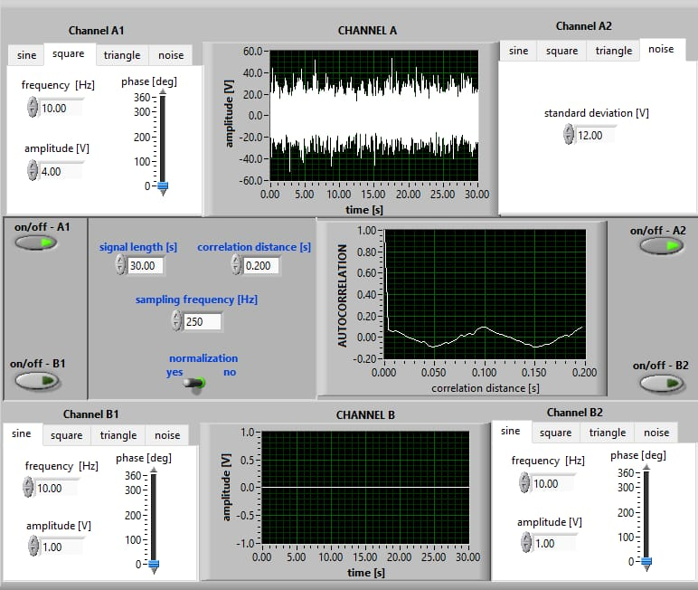
Standard deviation = 12 Amplitude = 4
N = σ_{sq}² + σ_{noise}² = 144 + 16 = 160s
ε = $\frac{σnoise^2 }{N} x 100$ = $\frac{144 }{160} x 100=\%90$

Conclusion
This experiment successfully highlights the application of autocorrelation in signal processing for different signal types. Key takeaways include:
- The importance of selecting appropriate τmax\tau_{max}τmax​ and ensuring τmax≪T\tau_{max} \ll Tτmax​≪T for accurate function estimation.
- Stationarity tests confirm that signal length and reduced noise enhance correlation stability.
- Qxx(τ)Q_{xx}(\tau)Qxx​(τ) distributions reveal distinct behaviors for various signal-noise compositions, showcasing autocorrelation's utility in distinguishing deterministic and random components.
Future work may involve applying these principles to real-world signals in communications or audio processing to explore autocorrelation's potential further.

